Janata Shikshan Sanstha’s
Kisan Veer Mahavidyalaya, Wai
Departments of Economics, Commerce and Zoology
Report of One Day Workshop on “How to Manage Money and be Smart Investor” – 11th December 2019
One Day workshop on “How to Manage Money and be a Smart Investor” was organized by Departments of Economics, Commerce and Zoology of our college in association with NSE’s Investor Protection Fund Trust and Consumer Guidance Society of India on 11th December 2019. India is vast developing nation in the world and has huge consumer potential from world point of view. Indians are consumers of goods and services produced in inland and international level financial services and products at both level as well. It is important from consumer point of view that, they must aware and know their right and obligation as consumer of products and services. If consumer could be well aware of his rights and obligations then his interest can be preserved. This is the main aim and focusing area of this workshop.
Dr. R.S. Gavit welcomed Chief Guests, Chairperson, all staff and student of programme and requested to all dignitaries on dais to inaugurate programme by enlighten the holy lamp and offer flowers to frames of Hon. Abasaheb Veer and Hon. Laxman Shatri Joshi. Prof. Dr. I. F. Pailwan presented introduction of programme and intention behind organization of such programme. Besides he also introduced the chief guest of programme. Prof. Manoj Pawar from Consumer Guidance Society of India conducted 1st session on awareness of consumer rights and laws. He firstly spoke on transaction between traders and buyers of selling and buying goods and services. Then he explained the mistakes consumer consummates during his transaction with traders and how the traders promises and fails to fulfill it. Prof. Pawar made aware with such cases of consumer deception and depth of financial loss incurred by consumer due to lack of knowledge about consumer rights and laws. He appealed to every participant in programme that, every person should go with proper methods of buying and selling activity so that any discrepancy can regarding easily ruled out without financial loss. At the end of his session, he briefly talked on consumer law and rights and how these are beneficial from consumer point of view.
Mrs. Prachi Mayekar from NSE’s Investor Protection Fund Trust has conducted 2nd session followed by short break on smart investment. Every human being is not self-dependent, he has to depend on every need that he could not fulfill by him own self. Through means of payments he can relies on others to fulfill his own wants so every individual assigns himself for creating financial assets. Assets are important but earning assets have great importance from income point of view. Assets classification and proper planning is prerequisite to avoid big loss. In her detailed speech, she covered above topics and made aware students with different financial assets and how it work as well as appealed to start creating own portfolio sooner to reach early at your decided goals.
At the end, Hon. Principal Dr. C. G. Yeole in their speech offered sincere thanks to NSE’s Investor Protection Fund Trust and Consumer Guidance Society of India for arranging such programme in our college. Hon. Principal appealed students to go proper and be legitimate in your transactions to avoid financial loss and its frustration. Academic and sound education is necessary but consumer rights and financial education has also significant now days, so all people should start the learning of financial education and be good aware with consumer rights and laws. About 87 Students along with Teaching and Non-teaching staff were participated in this progamme. Dr. M. T. Jadhav, presented vote of thanks and declared that, the programme is concluded by the permission of Chairman.

Prof. Manoj Pawar, CGSI, Inaugurating Programme
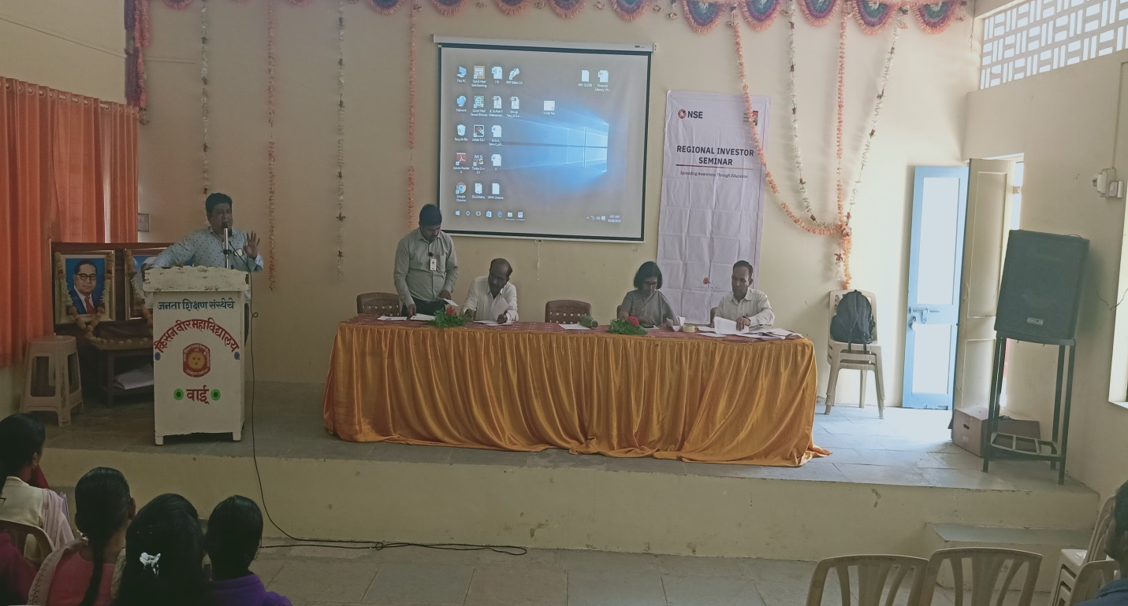
Miss. Prachi Mayekar, NSE, Introducing Programme
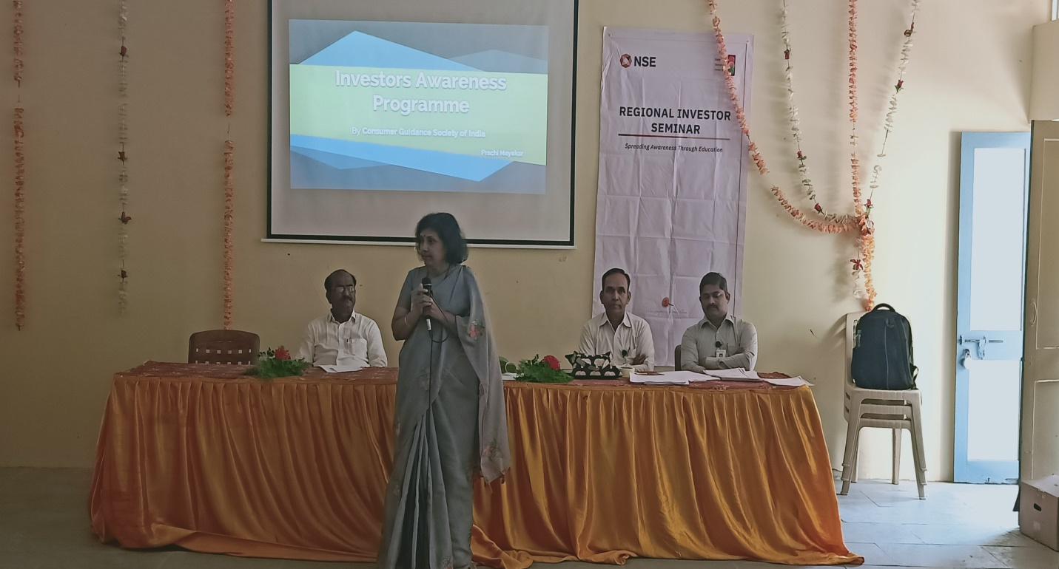

Miss. Prachi Mayekar, NSE, Addressing Students
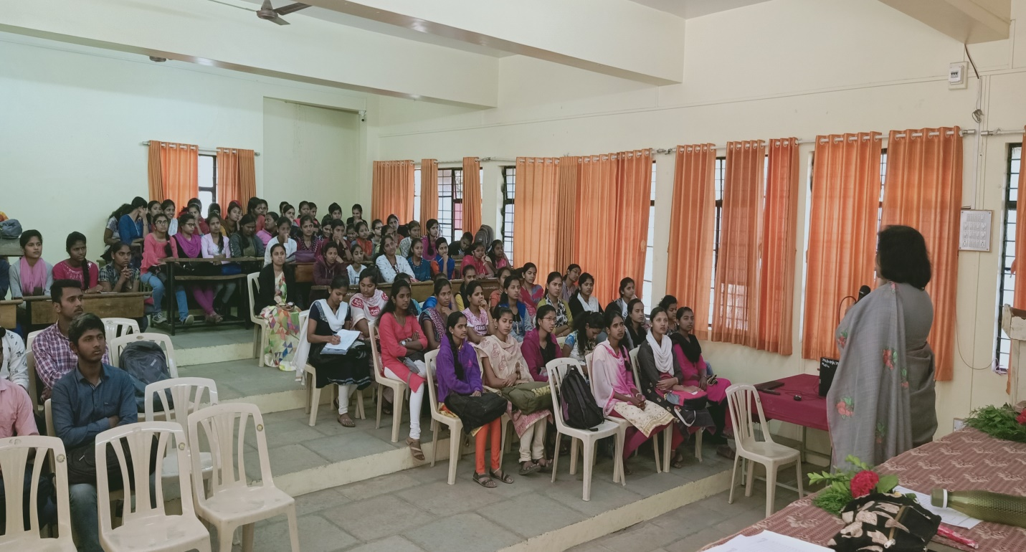
Participants of Programme
